COLLEGE OF COMPUTING AND INFORMATICS

UNIVERSITI TENAGA NASIONAL

B-SAFE BOAT TRACKING SYSTEM

MUHAMMAD ASHAARI BIN AZMAN

JANUARY 2020

B-SAFE BOAT TRACKING SYSTEM

by

MUHAMMAD ASHAARI BIN AZMAN

Project Supervisor: RAJA FENINFERINA RAJA AZMAN

PROJECT REPORT SUBMITTED IN PARTIAL FULFILLMENT OF THE

THE REQUIREMENTS FOR THE BACHELOR OF COMPUTER SCIENCE (SOFTWARE ENGINEERING) (HONS.)

UNIVERSITI TENAGA NASIONAL

JANUARY 2020

**APPROVAL PAGE**

**TITLE:** B-SAFE BOAT TRACKING SYSTEM

**AUTHOR:** MUHAMMAD ASHAARI BIN AZMAN

The undersigned certify that the above candidate has fulfilled the condition of the Final Year Project in partial fulfilment for the Bachelor of Computer Science (Software Engineering) (Hons.)

**SUPERVISOR:**

Signature: _______________________

Name: Raja Feninferina Raja Azman

Date: _______________________

**DECLARATION**

I hereby declare that this report, submitted to Universiti Tenaga Nasional as a partial fulfilment of the requirements for the Bachelor of Computer Science (Software Engineering) (Hons.) has not been submitted as an exercise for a bachelor at any other university. I also certify that the work described here is entirely my own except for excerpts and summaries whose sources are appropriately cited in the references.

This report may be made available within the university library and may be photocopied or loaned to other libraries for the purposes of consultation.

10/1/2020

___________________ MUHAMMAD ASHAARI BIN AZMAN

SW0103698

**ABSTRACT**

Maritime Search and Rescue Operation typically are straightforward and very organized in most cases. However, in certain incidents, the operations are not as smooth. This is usually caused by two things; inadequate resources, and info. While most sea-going vessels are equipped with trackers and beacon for emergency purposes, most small, privately run boats (especially tourist boats) do not have this feature. This is one of the causes of delayed rescue operations; inadequate information and data due to lack of tracking system onboard. The root cause for this problem is likely that the cost of implementing one for such small vessels are not worth it, and the complexity and technicality of learning to operate such system is too much for most of these small boat drivers. B-Safe Boat Tracking system aims to remedy this by providing a simple-to-use, affordable boat tracking system by using simple and interactive User Interface, developed on android mobile platform where it comprises about 85% of world’s smartphone user. The system should be able to assist SAR teams and operatives in their operations for a smoother pinpointing of the victims in the “search” phase of the missions.

**ACKNOWLEDGEMENT**

We are grateful to UNITEN for giving us this great opportunity to partake in Final year project. This is the opportunity that we can have to create the imaginations that we have in our minds and bring it to reality in the needs of helping our society.

We also wish to present a very high appreciation to our supervisor Raja Feninferina Raja Azman for a helping hand and contribution ideas and the constructive proposal by sharing us the expertise needed to complete this project. We sincerely appreciate the time spent on proofreading and correcting our mistakes. With the help from him, we manage to undertake this project smoothly and orderly with the advice and encouragement given.

Our sincere thanks also to Ms.Ramona Ramli, Head of Final Year Project (FYP) 1 coordinator for providing us with all the necessary facilities for the research have invested time and effort in coordinating the FYP 1. Many special thanks go to our presentation panel for their excellent co-operation, inspiration and supports during this FYP.

1. Finally, we express our gratefulness to all the departments faculty members for their help and our family for the unceasing encouragement, support and attention given to us. The immense love and moral support everyone have given to us are truly unmeasurable.

TABLE OF CONTENTS­­­

Page

APPROVAL PAGE III

DECLARATION IV

ABSTRACT V

ACKNOWLEDGEMENT VI

TABLE OF CONTENTS VII

LIST OF TABLES Error! Bookmark not defined.

LIST OF FIGURES Error! Bookmark not defined.

LIST OF ABBREVIATIONS/NOTATIONS/GLOSSARY OF TERMS Error! Bookmark not defined.

CHAPTER 1 INTRODUCTION Error! Bookmark not defined.

1.1 Project Background **Error! Bookmark not defined.**

1.2 Problem Statements **Error! Bookmark not defined.**

1.3 Project Objectives **Error! Bookmark not defined.**

1.4 Project Scopes **Error! Bookmark not defined.**

CHAPTER 2 METHODOLOGY Error! Bookmark not defined.

2.1 Review on Existing Systems **Error! Bookmark not defined.**

2.1.1 System 1 **Error! Bookmark not defined.**

2.1.2 System 2 **Error! Bookmark not defined.**

2.1.3 System 3 **Error! Bookmark not defined.**

2.2 Finding and Analysis **Error! Bookmark not defined.**

CHAPTER 3 SYSTEM DESIGN Error! Bookmark not defined.

3.1 Requirements Elicitation **Error! Bookmark not defined.**

3.1.1 Elicitation Technique(s) 10

3.2 Results and Discussion **Error! Bookmark not defined.**

3.3 Requirement Specifications **Error! Bookmark not defined.**

CHAPTER 4 SYSTEM DESIGN Error! Bookmark not defined.

4.1 System Design **Error! Bookmark not defined.**

4.2 System architecture **Error! Bookmark not defined.**

4.3 Interface Design **Error! Bookmark not defined.**

4.4 Database Design **Error! Bookmark not defined.**

CHAPTER 5 CONCLUSION AND DISCUSSION Error! Bookmark not defined.

5.1 Conclusion **Error! Bookmark not defined.**

REFERENCES 35

APPENDIX A: SOFTWARE REQUIREMENTS

SPECIFICATIONS Error! Bookmark not defined.

CHAPTER 1

INTRODUCTION

**1.1 Project Background**

Tourism, being one of Malaysia’s major income revenue sector, has been going strong for decades in the industry. Malaysia has come far in improving and utilizing its strength as the major tourist hotspot in southeast Asia, emphasizing on the multicultural aspect of the country to provide tourist a mix of what Asia has to offer, all in one place.

However, many local tourism service providers operating autonomously have minimal or not at all any form of standardized safety guidelines or protocols in practice. Main reasons being:

1. No provision from the ministry

2. Lacks of funding to enforce any safety standard

One particular observation can be made are among local nautical tourist service provider (island hopping, boat rental) among the many islands in Malaysia. The way these local’s provider operates are with bare minimum safety measure (life jackets, on-board emergency buoy), which deals only with on-incident measure. However, little emphasize are made in handling the post-crisis action among these local service providers, which mostly involves Search-and-Rescue operation. These operations are hindered by the fact that there is no systematic standards or technology employed by these locals to ensure

The project proposes a solution to assist the post-incident SAR operation by equipping the local tourist boat service provider with a cross-platform system (mobile device) that serve as a real-time transmitter for footprints of the whereabout of the boat driver to the dashboard (on-shore device). The driver does this by starting a tracking session on his mobile device, in which the device will ping the dashboard at a set interval amount of time. Abrupt termination of the sessions denotes a possible emergency or incidents happening to the driver, in which the system will alert the system administrator / responder for further action.

**1.2 Problem Statement**

**Lacks of tracking system for local tourism boats service**

Boats used in nautical tourism (island hopping, boat rentals) lacks post-incident safety measure, namely a tracking system that is capable of relaying their location to a remote monitor. This hinders Search-and-Rescue operation in case of incidents and emergency such as equipment failure and capsizes. Some deaths in these related incidents are caused by delay of the responder team to reach to the incident area, which mainly caused by no prior information on the whereabouts of the vessels.

* 1. **Project Objective**

This project aims to achieve these two main objectives, which is:

1. **To provide a live tracking system for service tourist boats**

The system proposed aim to allow user to ping their location to the system at a set interval of time in order to give “footprints” to the system. Users do this by using a smart device on their end as a signal transmitter that pings the system continuously. The system then records the ping location, interval and timestamp, maps it onto a map to provide pathway view for responders and system monitor / administrator.

1. **To provide estimation of plausible searching range to assist SAR operation**   
   In case of emergency, the system can perform analysis based on the last received footprints of the device, duration between the timestamp and current time, and environmental variation (weather and wind, water current) to provide the responders and system monitor an estimate for an effective search radius and perimeter
   1. **Project Scope**

**User scope**

|  |  |
| --- | --- |
| Registration and login | Users are able to register their information and credentials, and able to login using such credentials. |
| Start and stop tracking session | Users are able to start and stop tracking their location while onboard a vessel, transmitting their location and timestamps over the duration of the trip |
| Edit, Update and Delete Credentials (user) | Users are able to edit and update any changes to their account information and credentials, or remove their account entirely from the system. |
| View tracking history | Users are able to view their previous trips’ history (pathway, duration, distance travelled). |

**Administrator / monitor scope**

|  |  |
| --- | --- |
| View current sessions | System admin is able to view currently ongoing sessions on a live-updated map |
| Receive and broadcast notification by User | System admin is able to receive real-time live notification from users currently on or finished their voyage. Admin is also able to broadcast said notification to other active user. |
| Receive signal termination alert | System admin is able to receive notification if a device that is transmitting their location stops transmitting abruptly (without user’s voluntary action) |

**System scope**

|  |  |
| --- | --- |
| Credentials storage | The system is able to store user’s details and credentials for authentication and authorization purposes |
| Receive and store tracking footprints | The system is able to receive transmitted footprints and store them in a dedicated database for recalls |
| Display footprints mapping | The system is able to map the received footprints on a map to be displayed to the system administrator / user |
| Session termination alert | The system is able to alert the system administrator of any current user that terminates its tracking session manually or involuntarily |

CHAPTER 2

RELATED WORKS

* 1. **Review on existing system**

Comparison made on two of currently similar system related to the subject of this project finds that while the current systems in place cover the general security measure requirement, some niche sector are not covered. Within the project context, the tourist boat service provider. The boat tracking system shows the most similarity with the currently in use Vessel Traffic Service, where the purpose of the VTS is to monitor vessels in local water continuously. However, VTS is only applicable to large vessels that are registered under the system. The proposed Boat Tracking System covers this redundancy by instead of registering the vessel, it requires the personnel in charge of piloting the vessel to register instead, and the system tracks the device carried by the personnel (Mobile Device), not a specialized onboard GPS tracker device.

**System 1 – Google’s Find My Device**

This system employed by Google serves as an emergency device tracker that is able to locate any registered mobile to a pinpoint precision. The system employs both GPS and internet connection to maintain transmission between the devices and the system. The system allows for the user to ring, lock or even wipe out the data on their device remotely. 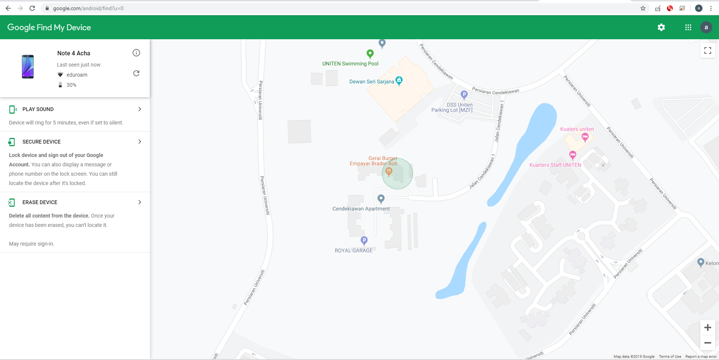

*Figure 2.1: Google Track My Phone Interface*

**System 2 – Vessel Traffic Service (VTS)**

VTS is an integrated vessel monitoring multi-system mainly purposed for controlling and managing pathway of vessels in deep sea and shallow waters near harbours. The system provides live tracking of registered vessels under the system, which allows the user to see pathways of the vessels, the vessel information, its origin and destination,

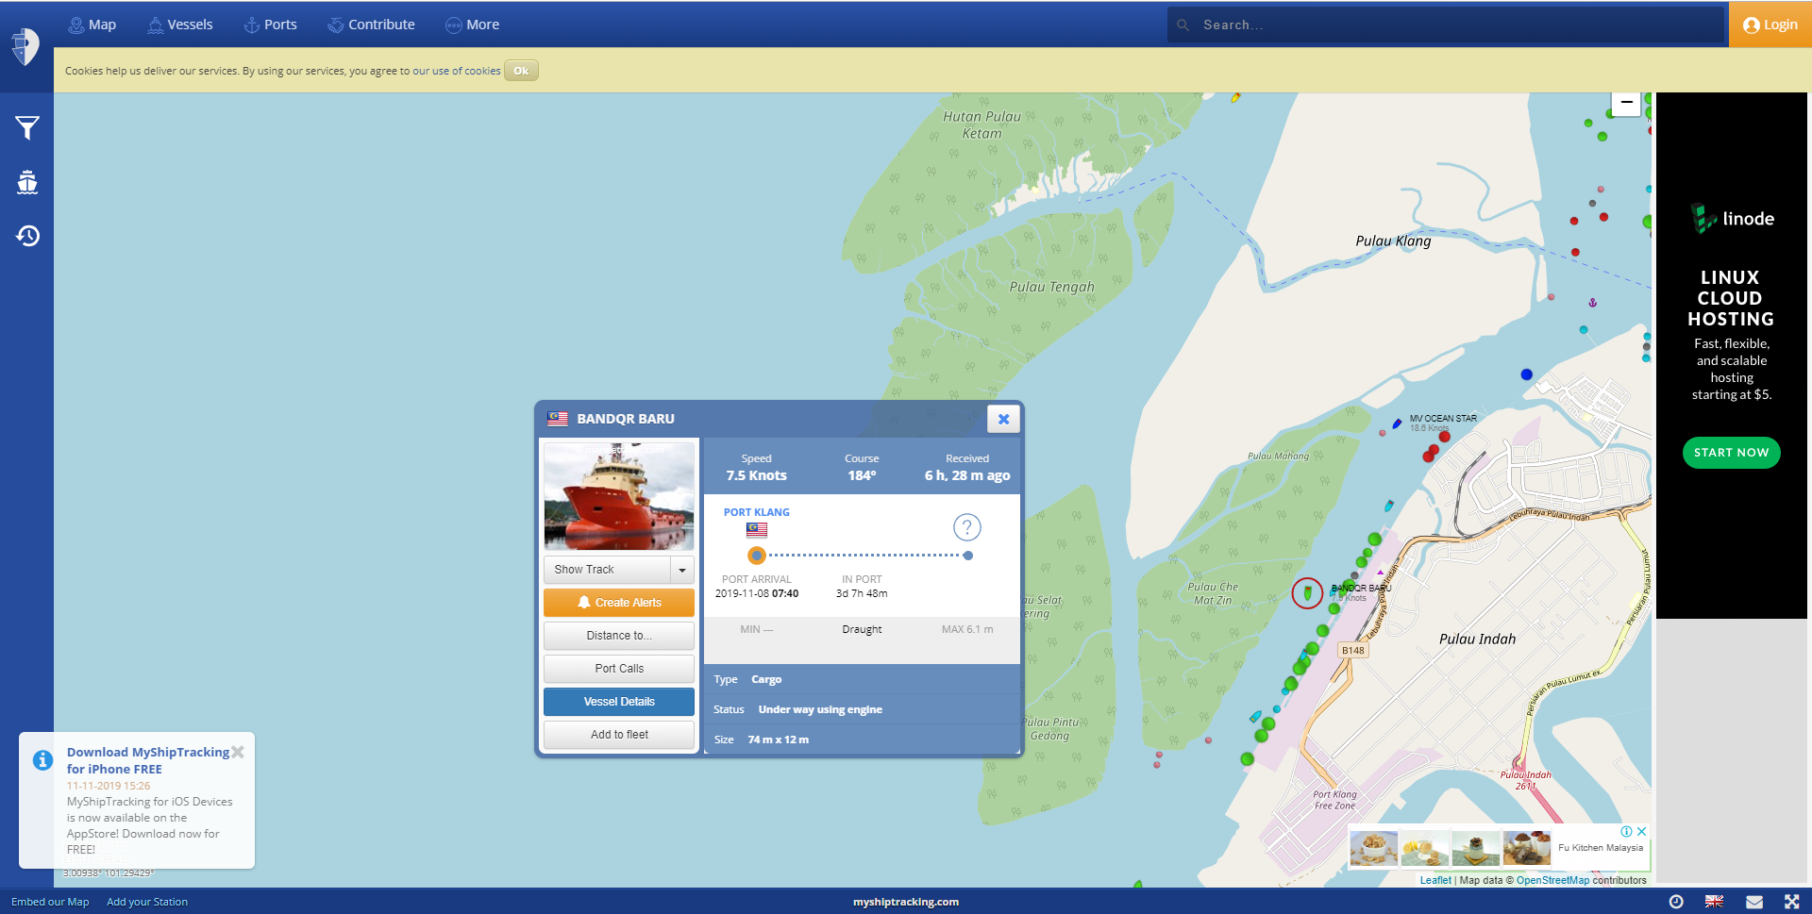

*Figure 2.2: VTS Map Navigation Interface*

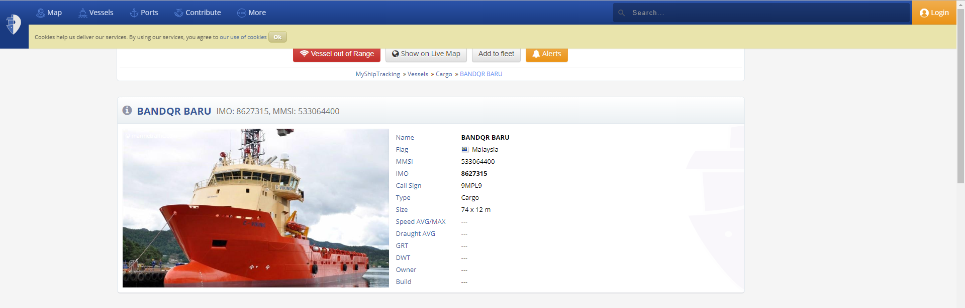

*Figure 2.3: VTS Vessel Detail Interface*

* 1. **Finding Analysis**

**Table 2.4: Comparison of the 3 system**

|  |  |  |  |
| --- | --- | --- | --- |
| Feature / System | Google Find My Device | Vessel Traffic Service | B-Safe Boat Tracking System |
| GPS tracking capability | Yes | Yes | Yes |
| Pathway visualization | No | Yes | Yes |
| Direct user notification (noise alert, text) | Yes | No | No |
| Show user / device details | Yes | Yes | Yes |

**CHAPTER 3**

**REQUIREMENT ANALYSIS**

**3.1 Requirement Elicitation**

The requirement gathering process was conducted by two methodology; Interview and Observation.

### Elicitation Technique(s)

1. Interview

A 3-phase interview session with the operation officer in charge at National Disaster Management Agency (NADMA) was conducted to give better understanding of how maritime-related search-and-rescue operations are done, the procedures outlines and authorities involved in such operation.

1. Observation

Observation of sea-going small vessels are conducted in two local piers;

1. Bagan Datoh fisherman pier, Perak
2. Kuah Commercial pier, Langkawi, Perak

The sea-going vessels are mostly comprised of fishermen’s and tourist boats. The observation sub-activity includes;

1. On-board device inspection
2. Protocol and procedures for voyages
3. Safety measures in place for both the captain and passengers on-board

**3.2 Result and Discussion**

The interview was conducted in a 2-phase interview session with the staffs at National Disaster Management Agency (NADMA).

The first phase consists of a general presentation and small tour of the facility around NADMA, explaining regarding what is NADMA and their roles and relations in handling incidents (specifically in context with shallow-sea related incidents).

The second phase comprises of small interviews with the staffs and operatives, with a short debriefing afterwards. The following outcome is obtained from the questions posed:

|  |
| --- |
| 1. Chain of command & parties involved in case of SAR of above operation |
| Maritime SAR usually divided into two distinct jurisdictions over which party is responsible to conduct the ;   1. Below 9 nautical miles from the shore (shallow water): Fire and Rescue Department (Jabatan Bomba dan Penyelamat). 2. Above 9 nautical miles from the shore (deep water): Malaysian Maritime Enforcement Agency (formerly known as Malaysian Cost Guard). |
| 1. Typical time taken between an incident actually happening and its detection to be confirmed |
| Varying, as some sea-going vessels has emergency beacon equipped and some private and individual vessel are poorly equipped.  Time between incident report to confirmation could range between 5 to 30 minutes. |
| 1. Typical response time taken between upon incident confirmation to the rescue team to reach the vessel (inclusive of search / analysis phase) |
| Varies as the time taken to confirm the incident taking place during “search” phase and the capability of the rescue team to reach the site during the “rescue” phase greatly affects the overall response time for the whole operation. |
| 1. Current countermeasures / security policy in place for shallow water / shoreline vessels |
| 1. Increase of jurisdiction coverage by both Fire & Maritime Department 2. Joint operation with Royal Malaysian Navy in incidents that may pose threats to national security (capsizes outside of Malaysian boundaries, pirate attacks, intrusion) 3. Establishment and expansion of Special Malaysia Disaster Assistance and Rescue Team (SMART) as an elite secondary operatives for any SAR missions conducted both in Malaysia and internationally. |
| 1. Classification of any sea-going vessels (and protocols for rescue mission of these groupings) |
| Vessels are not classified in any specific classification, but the size and possible number of on-board crews determine the size of the operation and resources needed to |
| 1. Connection coverage around shallow waters / shores (2G, 3G, 4G, GPS) |
| Malaysia has not yet implemented 5g commercially, and while 4G connection are scarce around the shore, peninsular Malaysia enjoy clear coverage for 3G along the shoreline (especially around the west coast) and limited coverage in the shallow water near the shore. |
| 1. Factors contributing to failed SAR operations |
| SAR operations usually do not have “fail / success” status assigned to them, unlike a military / threat neutralization operations where objectives are |
| 1. Problems faced by the SAR team in routine operations |
| 1. Limited resources and manpower 2. Lack of knowledge of during-incident best course of action among the individuals affected 3. Changing and uncertain environment and terrain 4. Lack of precautions and safety measures |

Observation on the local piers found that most individually operated tourist boats has no tracking mechanism of any sort installed, and the safety measure installed were minimal to adequate;

1. Life jackets for every tourist onboard
2. 2 dated buoys
3. Handwritten voyage log & schedule

Upon further inspection, the boat driver of the vessels do not have formal maritime safety training, which many bodies and organization consider essential to boating.

Clearly the lack of any tracking system onboard the vessel means in case of emergency, the rescuer team will be hard-pressed to pinpoint the location for Maritime SAR Operation. Among the few reason given by the drivers are that:

1. A proper GPS tracker setup & maintenance costs a lot of money relatively for a small tourist boat
2. Complexity of proper utilizing as deterrent for most drivers (hesitant to learn because unfamiliarity with the technology)

This is the issue that the system proposed by this project aims to tackle; to provide an active tracking mechanism that allows for live-tracking of these individual vessels that can serve as a guide in case of emergency for the Maritime SAR Operatives.

**3.3 Requirement Specifications**

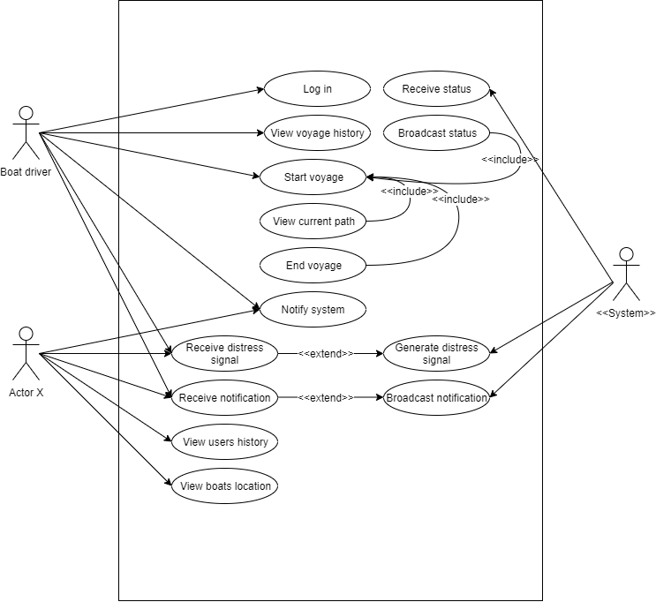

B-Safe Boat Tracking System

*Figure 3.1: B-Safe BTS Use Case Diagram*

The users (boat drivers) for the system is able to register his credentials to create an account and login to the system. The users are also able to view their past voyage history that contains information;

1. Starting date and time
2. End date and time
3. Voyage pathway
4. Remarks

Users can also start recording and trace their location by “starting the voyage” on the apps. The device will ping its location to a remote server that stores it in a database for future references. Then user can terminate their voyage session and also view the travelled pathway of the boat (device) during the voyage through the device.

The system monitors devices that is on voyage mode by receiving status broadcast from the user and determine whether the user is still on voyage, signal manually terminated (end voyage by user, device run out of power), or signal abruptly terminated (device stops working, ship capsizes and submerge in water). The system will then determine whether to generate distress signal to be sent to Actor X (responder, coast monitor) for further action. The system also manages manual notification sent by the users on voyage (depleted fuel, engine problem, missing tourist etc) and is able to broadcast said notification to all other users and Actor X for further actions.

**CHAPTER 4**

**SYSTEM DESIGN**

**4.1 System design**

The purpose of this chapter is to document the system specifications. The system design is divided into three parts which are system architecture, interface design and database design.

**4.2 System architecture**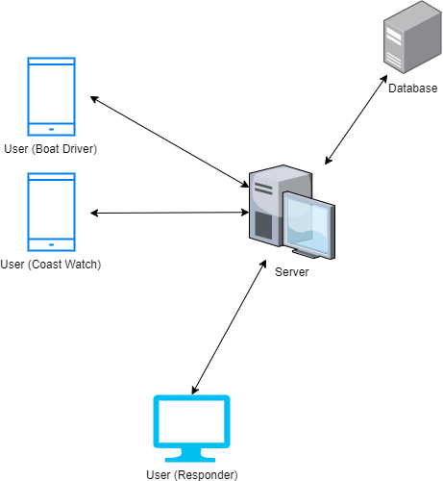

*Figure 4.1: B-SAFE BTS System Architecture*

The system comprises of:

1. User device, operated possibly by:
   1. Boat driver
   2. Coast watch (user that monitors the driver such as service owner)
   3. Responder (Authorities and rescue operatives)
2. Server machine
3. Database

Server machine serves as the logic processor and workload handler to process and analyse input from user devices, store and retrieve data to and from database, and also to make decision, broadcast signal & notification back to users.

The database receives processed data from server machine and is only accessible through the server machine, not the user devices, as the user device doesn’t have the capability to process the data from the database nor the processing power required.

**4.3 Interface Design**

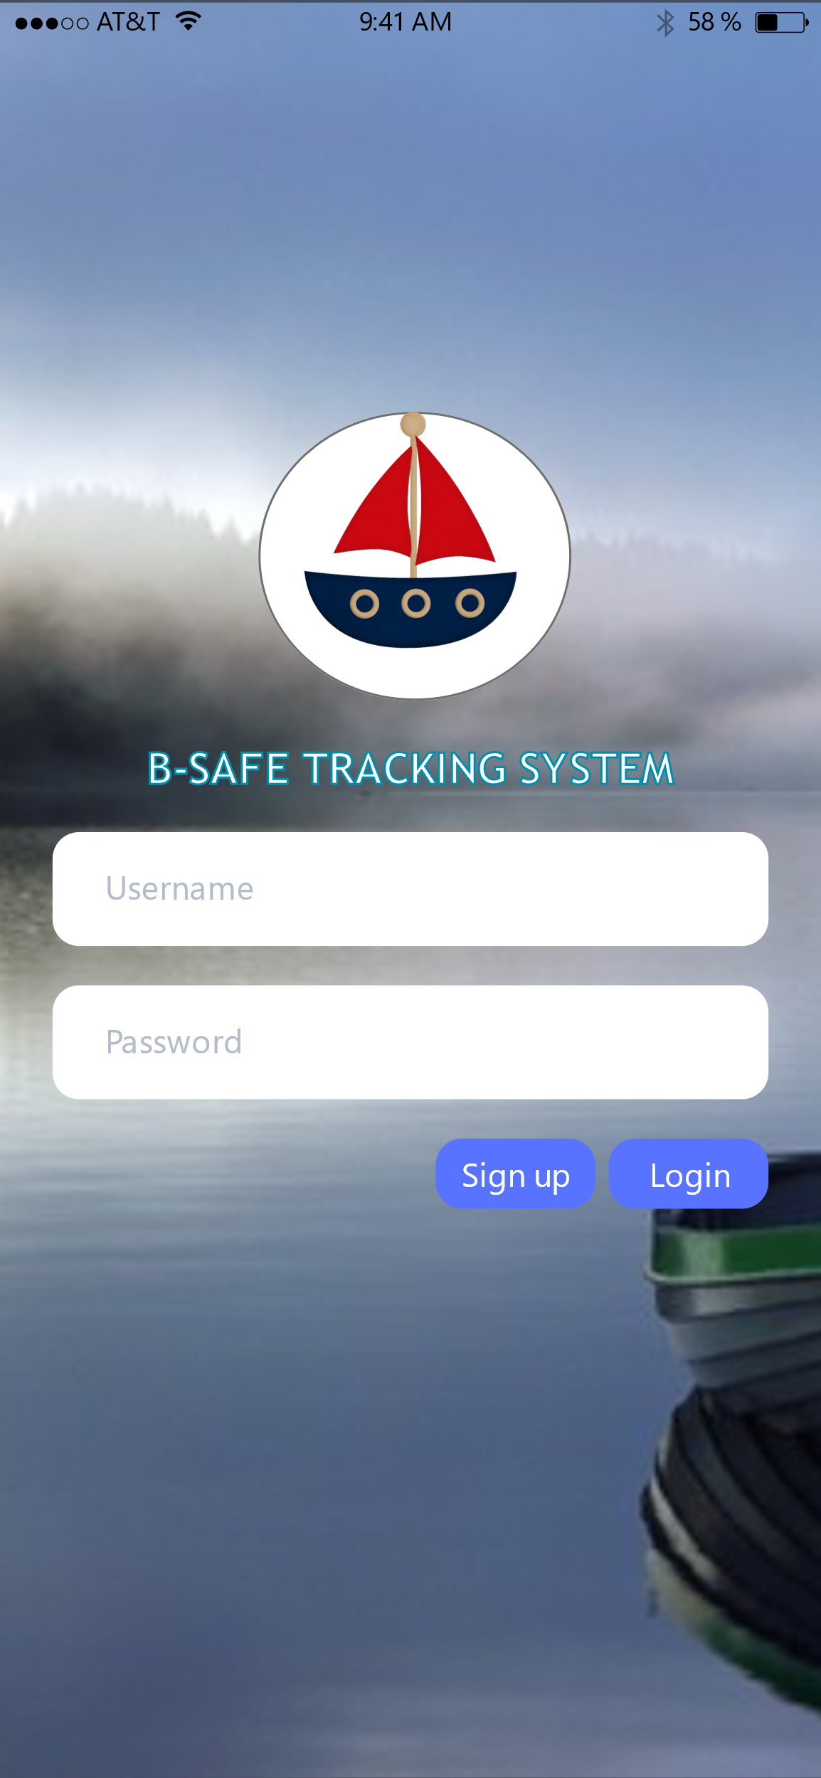

*Figure 4.3.1: B-SAFE BTS Login Interface*

A simple and straightforward login page is preferred as the target user for this system are not tech-savvy demographic.

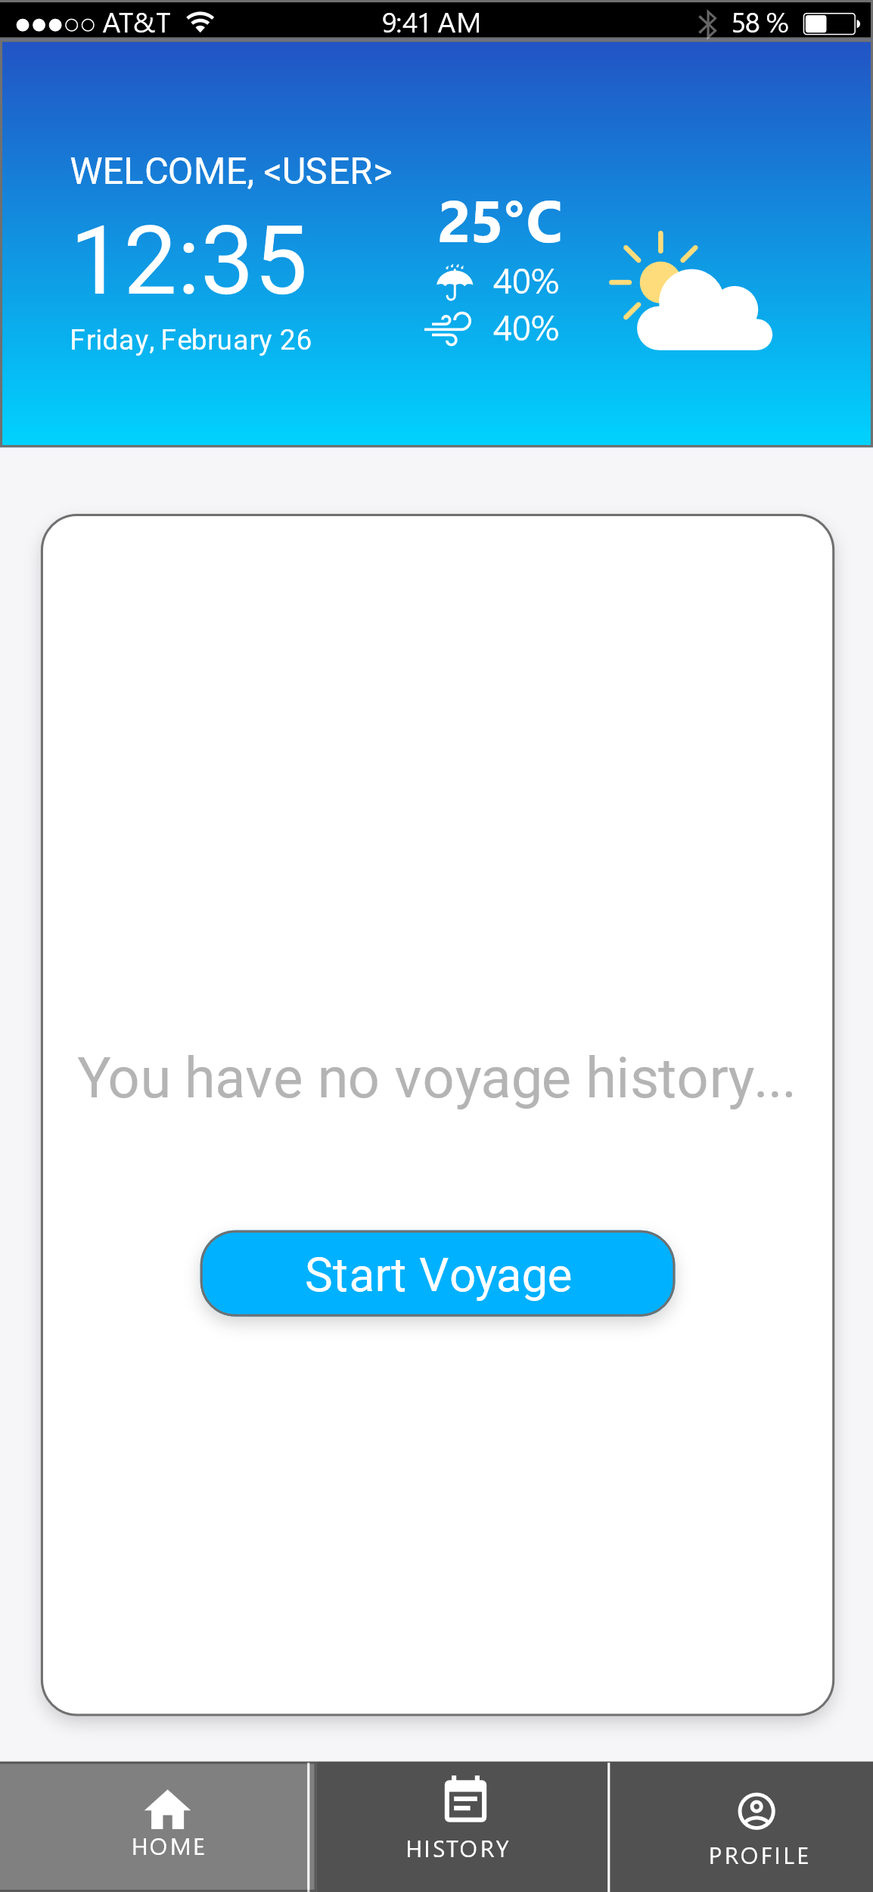

*Figure 4.3.2: B-SAFE BTS User Home Interface*

Upon logging in, user is taken straight to home page, where they are shown their recent activities and also a start button to enable the signal transmission straight away.

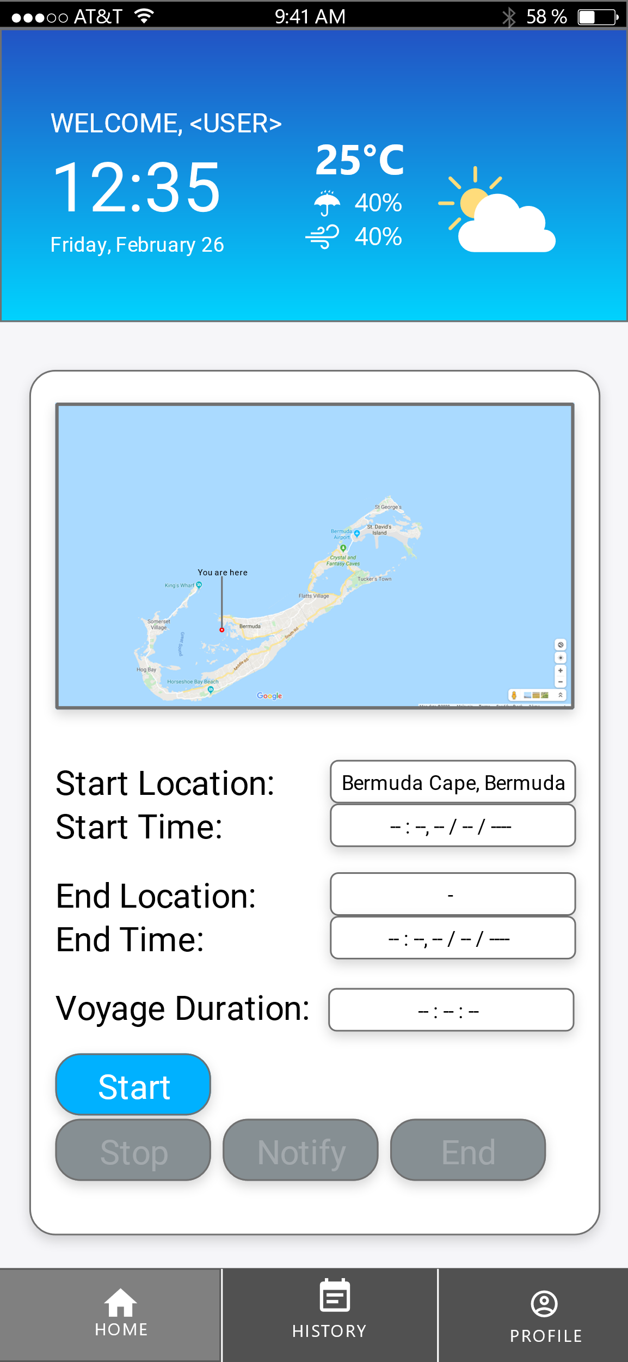

*Figure 4.3.3: B-SAFE BTS Start Voyage Interface*

The system will bring the user to this interface after clicking the “start voyage” button, where user can confirm their location and start their voyage when they’re ready to set out.

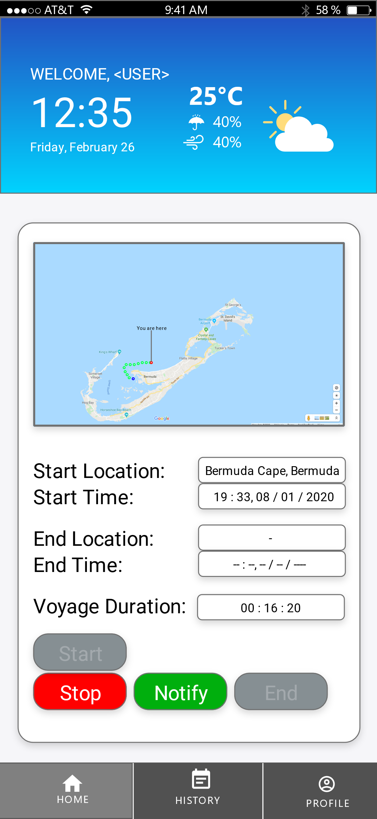

*Figure 4.3.4: B-SAFE BTS During-voyage Interface*

User can choose to stop their voyage denoting that they’ve stopped the tracker voluntarily, i.e, no problem encountered. User can also use the notify button to notify the Actor X (coast guard, spotter etc) about any issues / events encountered during their voyage.

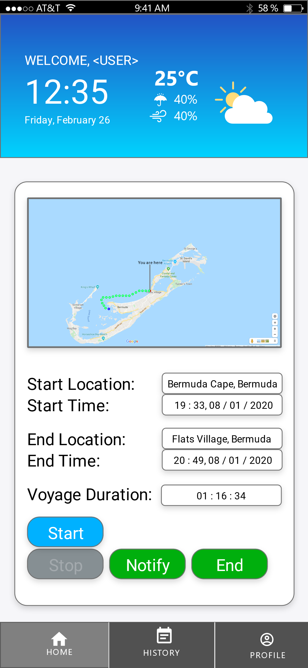

*Figure 4.3.5: B-SAFE BTS Finish-voyage Interface*

Upon ending the voyage, user can choose to start the voyage to start transmitting their location again to the server and to Actor X. User can also use the notify button to denote anything happening at their location. Finally, user can choose to end the transmission for good, confirming that there’ll be no more other stop further.

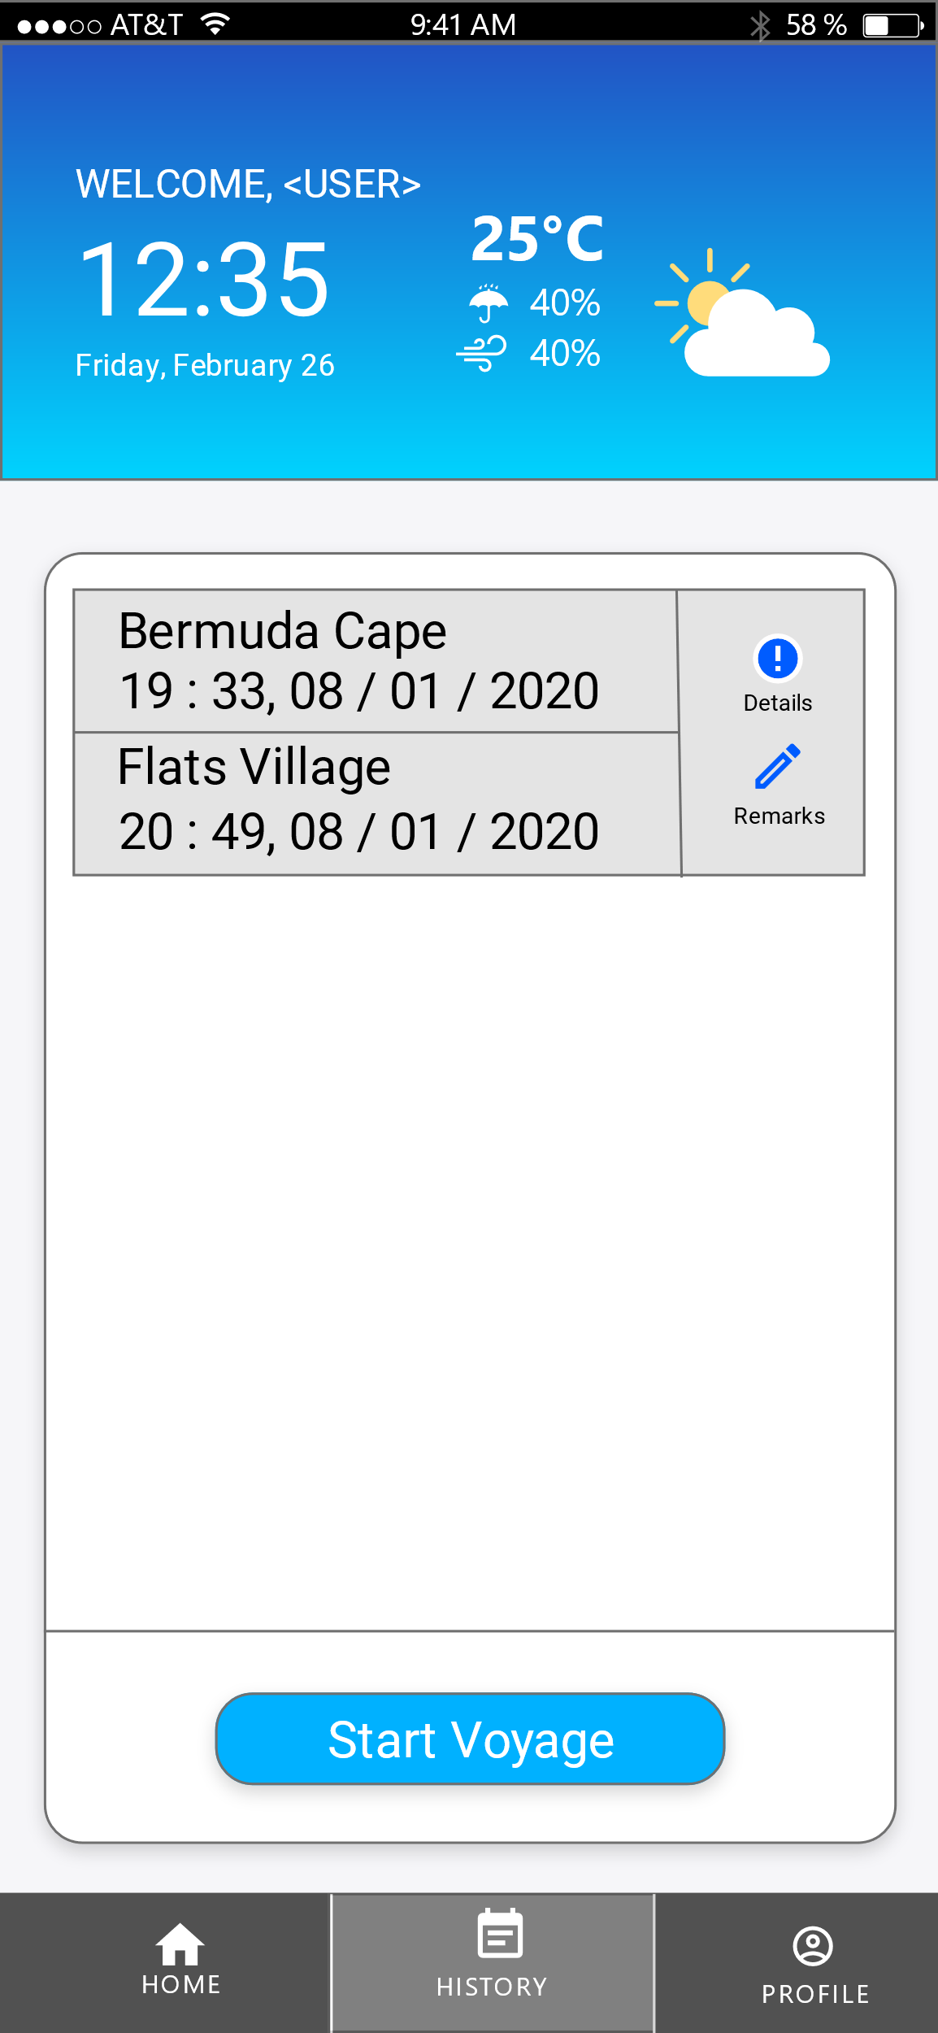

*Figure 4.3.6: B-SAFE BTS History Tab Interface*

On history tab, user can view the details of their previous voyage such as start/end location, duration, any issues encountered or remarks left and the duration of the voyage. User can also leave notes about the voyage on this tab for easier future reference.

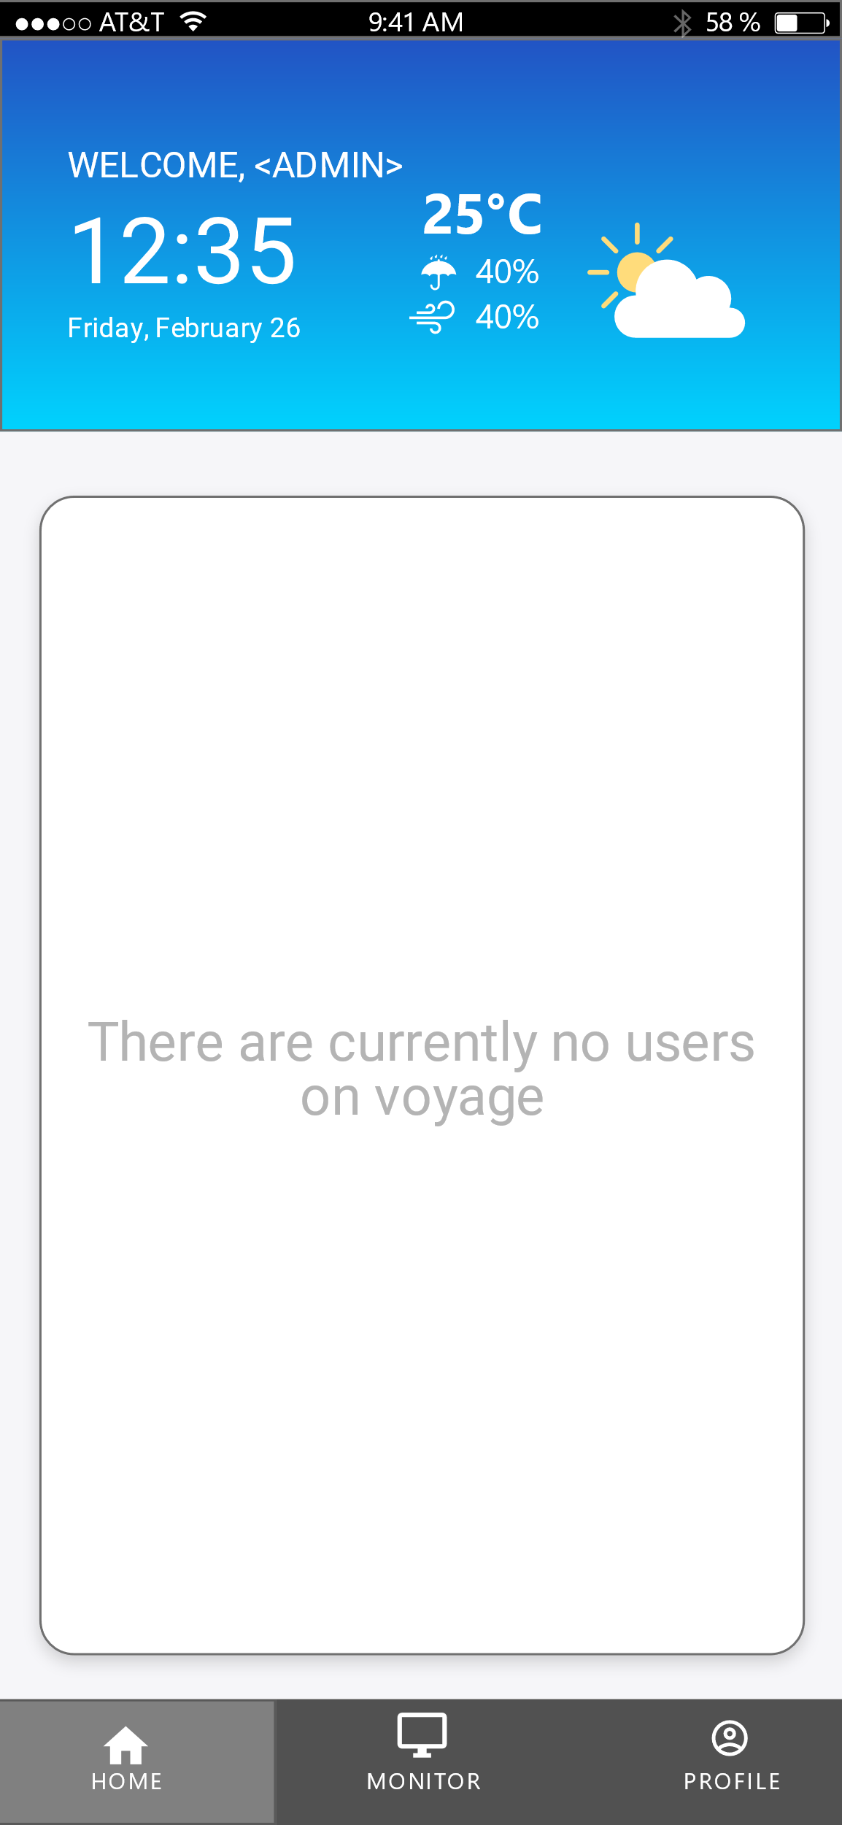

*Figure 4.3.7: B-SAFE BTS Spotter / Admin Home Tab (Empty)*

Logging in as admin (Actor X) gives a slightly different interface overall, as seen here where the home page denotes that no users are on voyage currently.

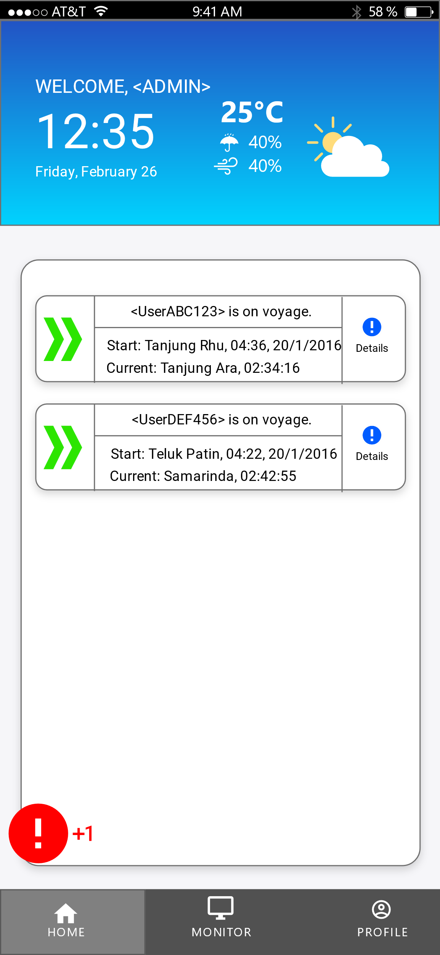

*Figure 4.3.8: B-SAFE BTS Admin Home Tab (filled)*

How the home page looks like when active users are on voyage or standby. Admin can click on the details button which brings them to an interface showing details of the user and his real-time location akin to the voyage details page from the user interface. Admin can also check on notification popups here.

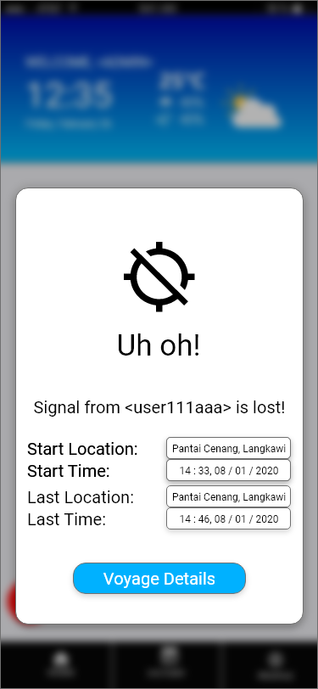

*Figure 4.3.9: B-SAFE BTS Warning Pop-ups*

Clicking on the warning popup will lead the admin to this page, where the admin can click on the button to view the voyage details straight away without having to look for it at the home tab or the monitor tab.

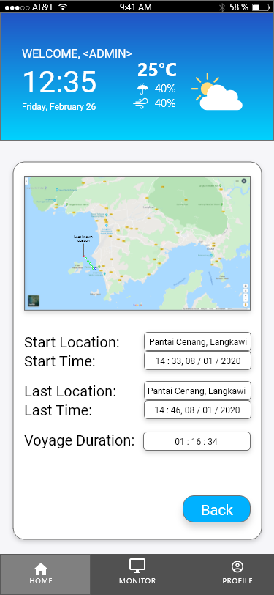

*Figure 4.3.10: B-SAFE BTS Warning Details*

Clicking on the voyage details through the warning popup modal will bring the admin to this window, where the admin can see the pathway of the user and his last known location along with other essential details of his voyage. The admin can then choose how to respond to this warning.

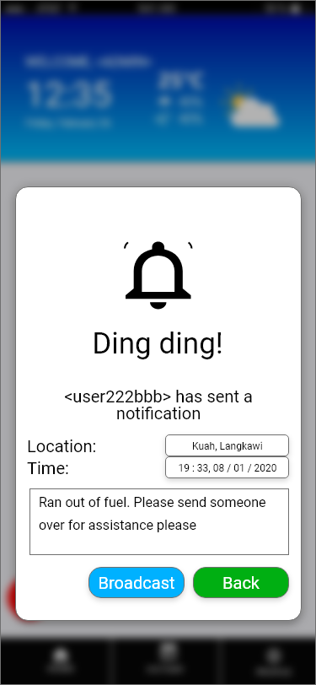

*Figure 4.3.11: B-SAFE BTS Notification Pop-ups*

Clicking on the notification popup will bring this modal up to notify the admin that a user has posted a notification and the admin can decide whether to broadcast it to all active user or respond to the notification individually.

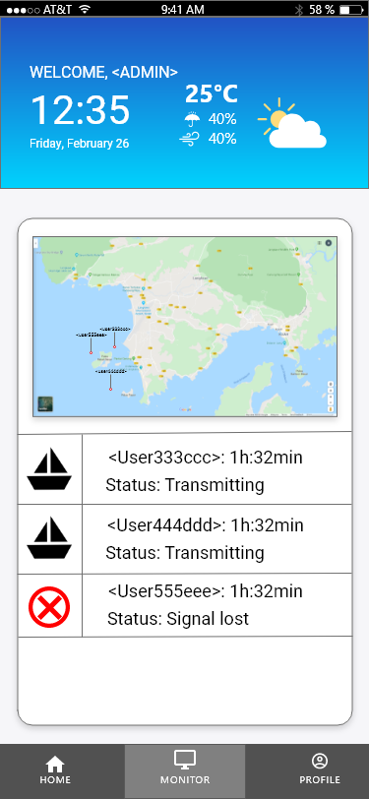

*Figure 4.3.12: B-SAFE BTS Monitor Tab*

In the monitor tab, the admin can view live location of all currently active user on voyage in a map along with their status. The admin can click on the username or icon to view the voyage details which will show the admin similar page like view voyage details page.

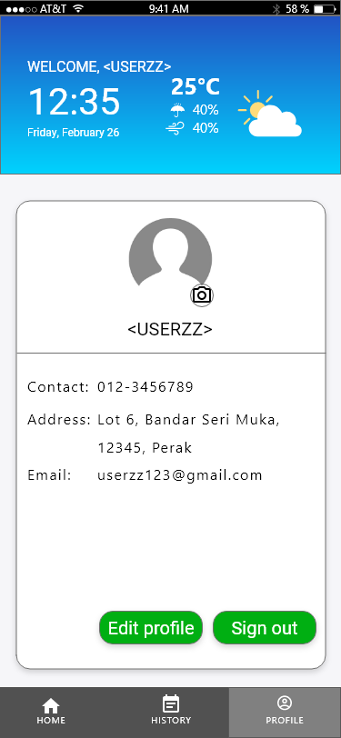

*Figure 4.3.13: B-SAFE BTS Profile Tab*

On profile tab, user can view and edit his/her details including the profile picture, contact number, address and emails.   
User can also sign out from the apps from this section, to remove themselves from active user from admin monitoring view.

* 1. **Database Design**

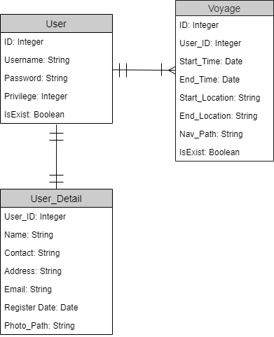

*Figure 4.4.1: ERD For B-SAFE BTS*

The database consist of 3 main tables:  
1. User  
2. User_Detail  
3. Voyage

The User table is used mainly for authentication and authorization process, while also holding the primary ID key for user attribute.

The User_Detail stores user information pertaining to the user.

Voyage table stores data for voyages made by users.

A user may have one-to-many relation with voyages, and one-to-one to user_details,

|  |  |  |  |  |  |
| --- | --- | --- | --- | --- | --- |
| Table | Column | DataType | Length | Acceptable Values | Description |
| User | ID | Integer | 10 | 0 - 9 | ID for User |
| User | Username | String | 20 |  | Login username used for login purpose |
| User | Password | Password | 20 | A – Z, 0 - 9 | Password for login purpose |
| User | Privilege | Integer | 2 | 0, 1, 2 | Access level |
| User | IsExist | Boolean | 3 | Boolean | Soft-delete purpose |
|  |  |  |  |  |  |
| User_Detail | User_ID | Integer | 10 | 0 – 9 | Foreign key, ID from User table |
| User_Detail | Name | String | 20 |  | Display name in the system |
| User_Detail | Contact | String | 20 | 0 – 9, ‘-‘ | Contact number |
| User_Detail | Address | String | 50 |  | Home address |
| User_Detail | Email | String | 30 |  | User’s email |
| User_Detail | Register_Date | Date | 20 |  | Date during account creation |
| User_Detail | Photo_Path | String | 100 |  | Pathway to user photo in storage |
|  |  |  |  |  |  |
| Voyage | ID | Integer | 10 | 0 – 9 | ID for voyage |
| Voyage | User_ID | Integer | 10 | 0 – 9 | Foreign key, ID from User table |
| Voyage | Start_Time | Date | 20 |  | Timestamp at start of transmission |
| Voyage | End_Time | Date | 20 |  | Timestamp at end of transmission |
| Voyage | Start_Location | String | 30 |  | Location at start of transmission |
| Voyage | End_Location | String | 30 |  | Location at end of transmission |
| Voyage | Remarks | String | 100 |  | Notes, remarks by user |
| Voyage | Nav_Path | String | 100 |  | Path to voyage’s raw data in storage |
| Voyage | IsExist | Boolean | 3 | Boolean | Soft-delete purpose |
|  |  |  |  |  |  |

**Table 4.4.2: Data Dictionary for B-SAFE BTS**

CHAPTER 5

CONCLUSION

**5.1 Conclusion**

The system proposed tackles the two main problem stated earlier in the report where:

1. Most boat drivers are not tech-savvy person. As such, they find installing and adapting to complicated and complex tracking system to be undesirable
2. Most tracking system costs a fortune to install and maintain. This deter most small tourist boating company to implement one in their operation.

The proposed system is to be developed on a mobile platform, which solves both of the problem above. It provides simplistic, easy-to-use UI on a smartphone that is capable of running android OS and iOS, which constitutes about 95% of current generation smartphone. This denotes affordability, especially for the target demographic aimed for this system.

REFERENCES